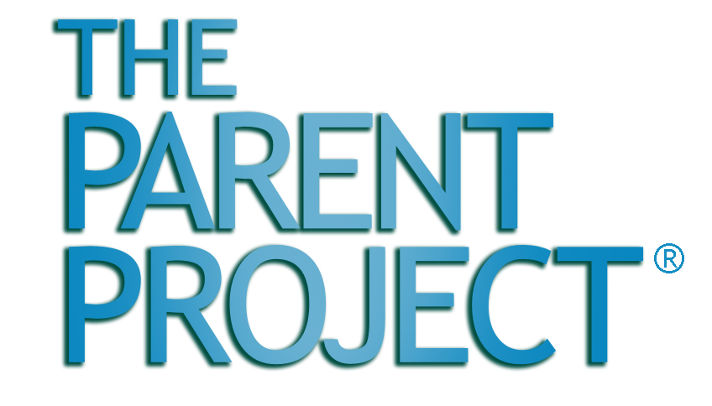

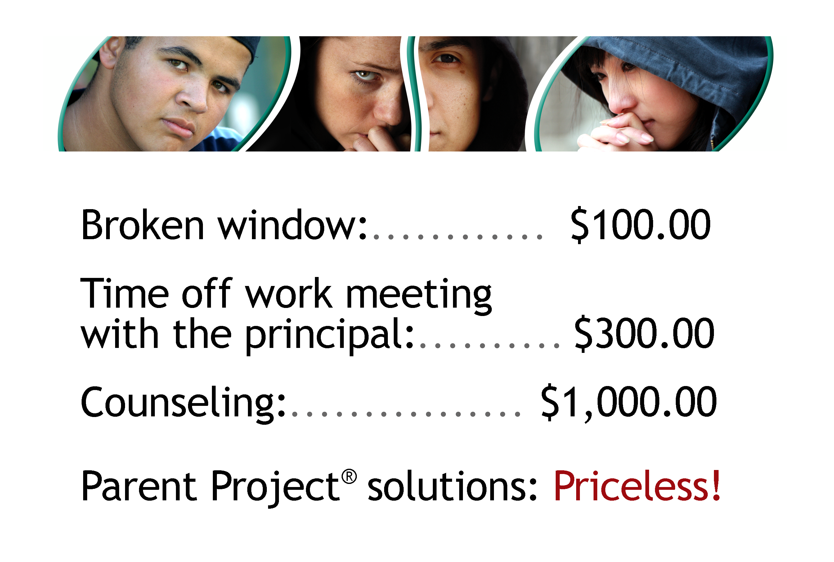
s
REGISTER NOW! No Cost Tuition : $25 Material Fee

Empowering Parents. Transforming Teens.

• Learn how to never argue with your child again!
• Prevent or intervene in alcohol or drug use!
• Improve school attendance and performance!
• Find resources to help your family!

10 Week Series Starts: Monday, April 10, 2009

XYZ High School • Call 213.1234.5678

1234 Correctional Way, Santa Barbara, CA

“For more information than My Space®, Come to our place!”

More info than 411! More tools than Home Depot!

